What is my selection for final project?
I decided my final project to be a combination of Recipes, Dinner and Shopping-List applications with an API to find the lowest price.

Why did I choose this as my final project?
- I am a trained and experienced Chef, so I have a lot of recipes.
- I already have a Java 8 Server to manage my recipes and need a client side.
- My beloved don't cook very well and for her to make a dinner it's a challenge.
- Our daughter likes to see the dish before I make it so she can approve it.
- I want a simple and easy way to create a shopping list by selected recipes for dinner.

How do I imagine the final outcome?
- Landing page:
+ Sticky Navbar on top.
+ Some text about the app.
+ At the bottom a carousel showing a few dishes and/or cakes.
- Recipes page:
Showing a gallery or list of recipes displaying some basic information:
The recipe name, image, short description, how long it takes to prepare and an
Add-To/Remove-FromDinner button.
Clicking the recipe will open Recipe Details page.
Clicking the “Add To Dinner” button will add the recipe to selected recipes and button text and functionality will change to “Remove From Dinner” which will remove the recipe from list of selected recipes.
- Recipe Details page:
This page show all details of a specific/selected recipe.
It shows the recipe name, a large image of recipe on the left, list of ingredients and preparation steps.
- Dinner page:
This page show the recipes selected for dinner for use review.
It shows the gallery of selected recipes using the same component used in Recipe page, but without the Add/Remove button.
- Shopping List page:
This page shows the list of products to buy based on the selected recipes. The application scans the selected recipes and extract the ingredients from them, in an ingredient is used in more than one recipe then it will appear once with the combined quantity to all recipes.
The list shows the name of the product, an image, the lowest price per unit, quantity, measuring units, total cost of product, and name of the shop in which has the cheapest price.
The cheapest price and name of the shop with the cheapest price for product are received from HTTP GET request API call to Price-Compare application using async/await.
Price-Compare application written in a Java 8, Springboot 5, MVC application with REST API and JSON data, running on localhost port 8080.
If the API returned with HTTP status-code 404 (NOT FOUND) it means the product was not found in the application data, the cheapest price will be 0.00 and cheapest shop name will have a text “(-1) Product Not Found in PriceApp”.

Which USER roles my final project will have?
- Guest – user without login, can see Recipes and Recipes Details pages.
- User – registered user, can see all pages and use the full functionality.
- Admin – Registered user that can also add new users and new recipes – Not implemented in the scope of the final project.

What will be the Tech Stack of my final project?
- HTML5
- CSS3
- JavaScript (ES6+)
- React v16+
- React-Bootstrap v4+
- Reactstrap v4+
- Java 8
- Spring Boot
- Spring MVC
- REST API
- JSON

Who can use my application?
- At first my application will be used by me and my family. I am the Admin and 2 users.
- Next phase my beloved and daughter can print the shopping list or send it to me by email.
- At later phases I plan to develop a secure login, a mobile app and sending the shopping list automatically to shops creating orders to be delivered to my home.
- I have some more ideas to expand the application, but it's for later.

Screens:
Landing / Home page
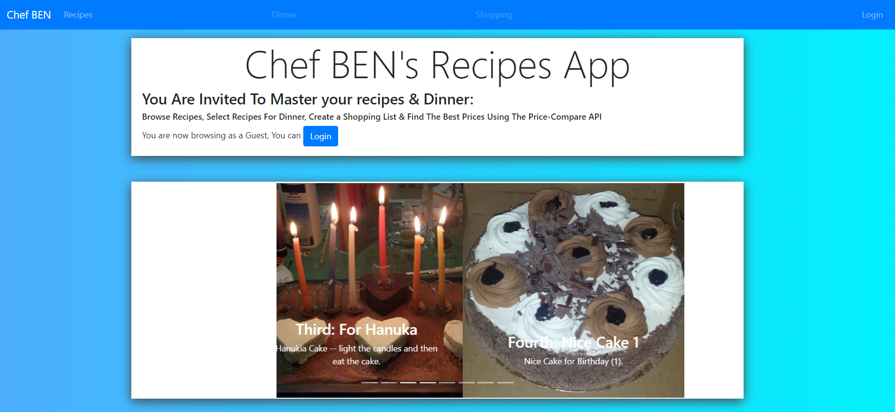

Login Page:
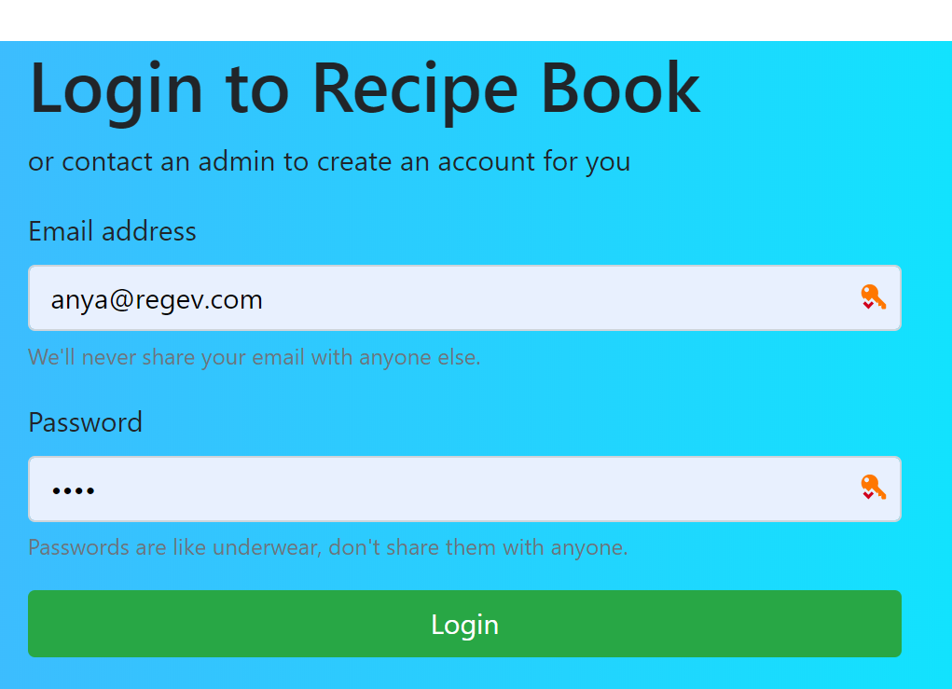
Recipes page:
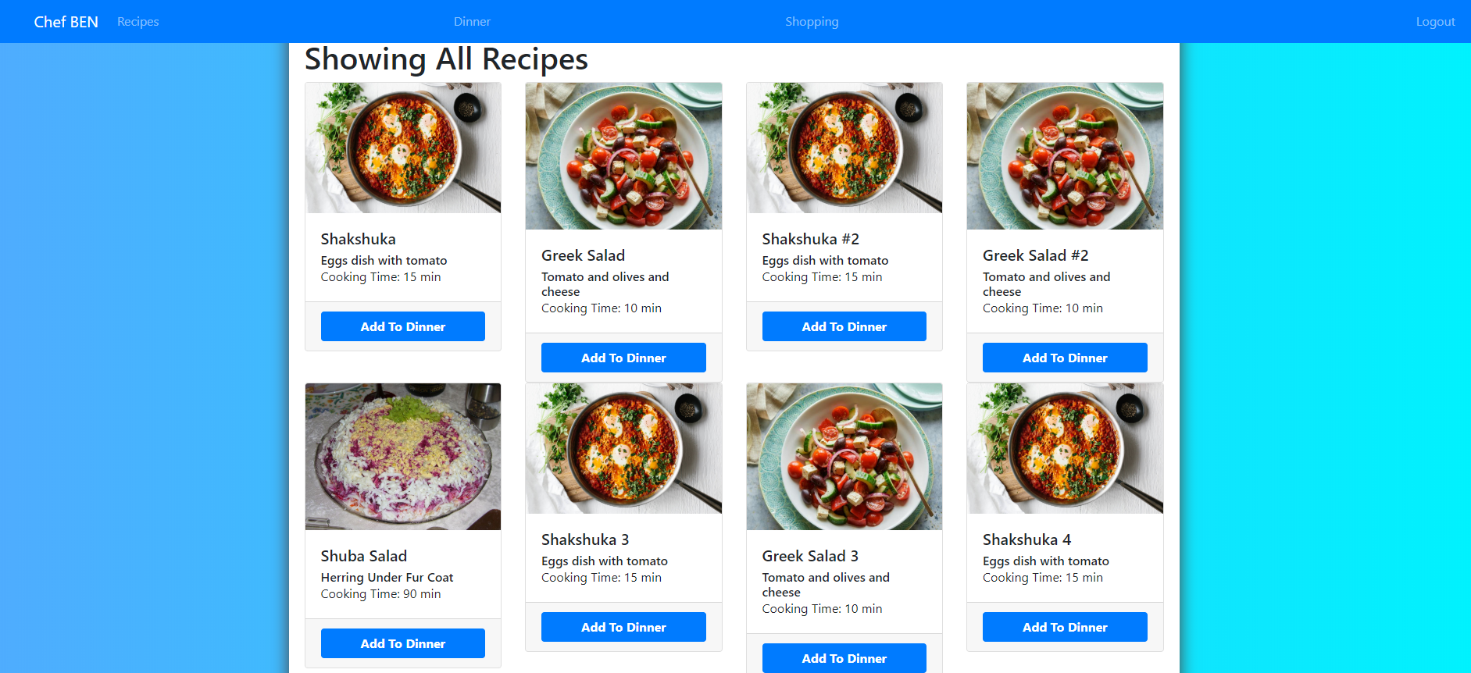
Recipe Details page:
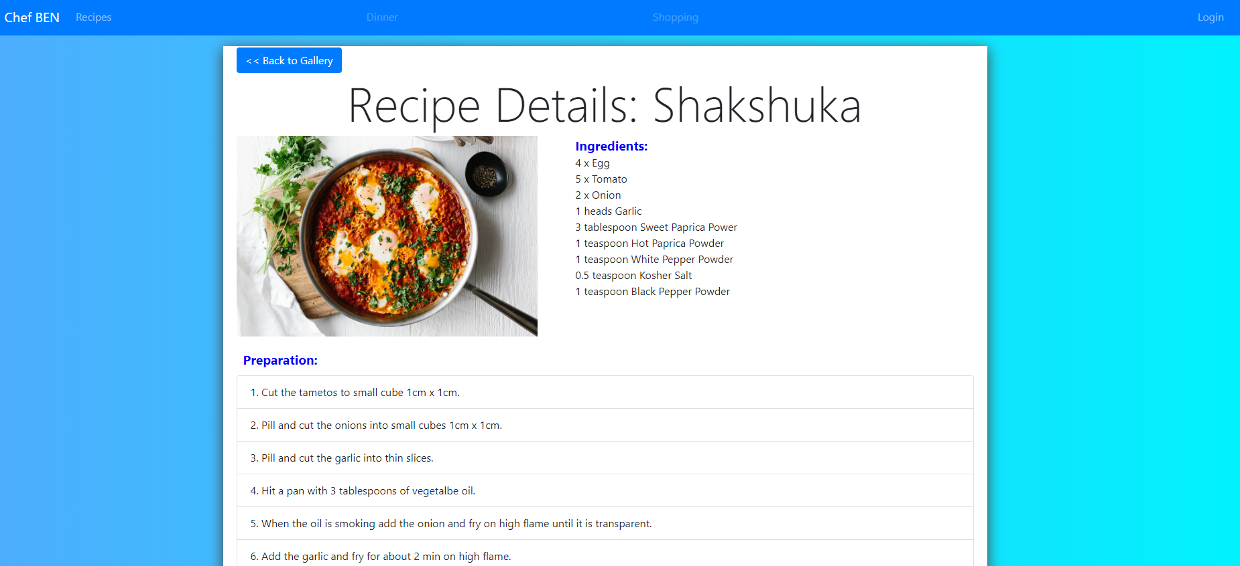
Dinner page:
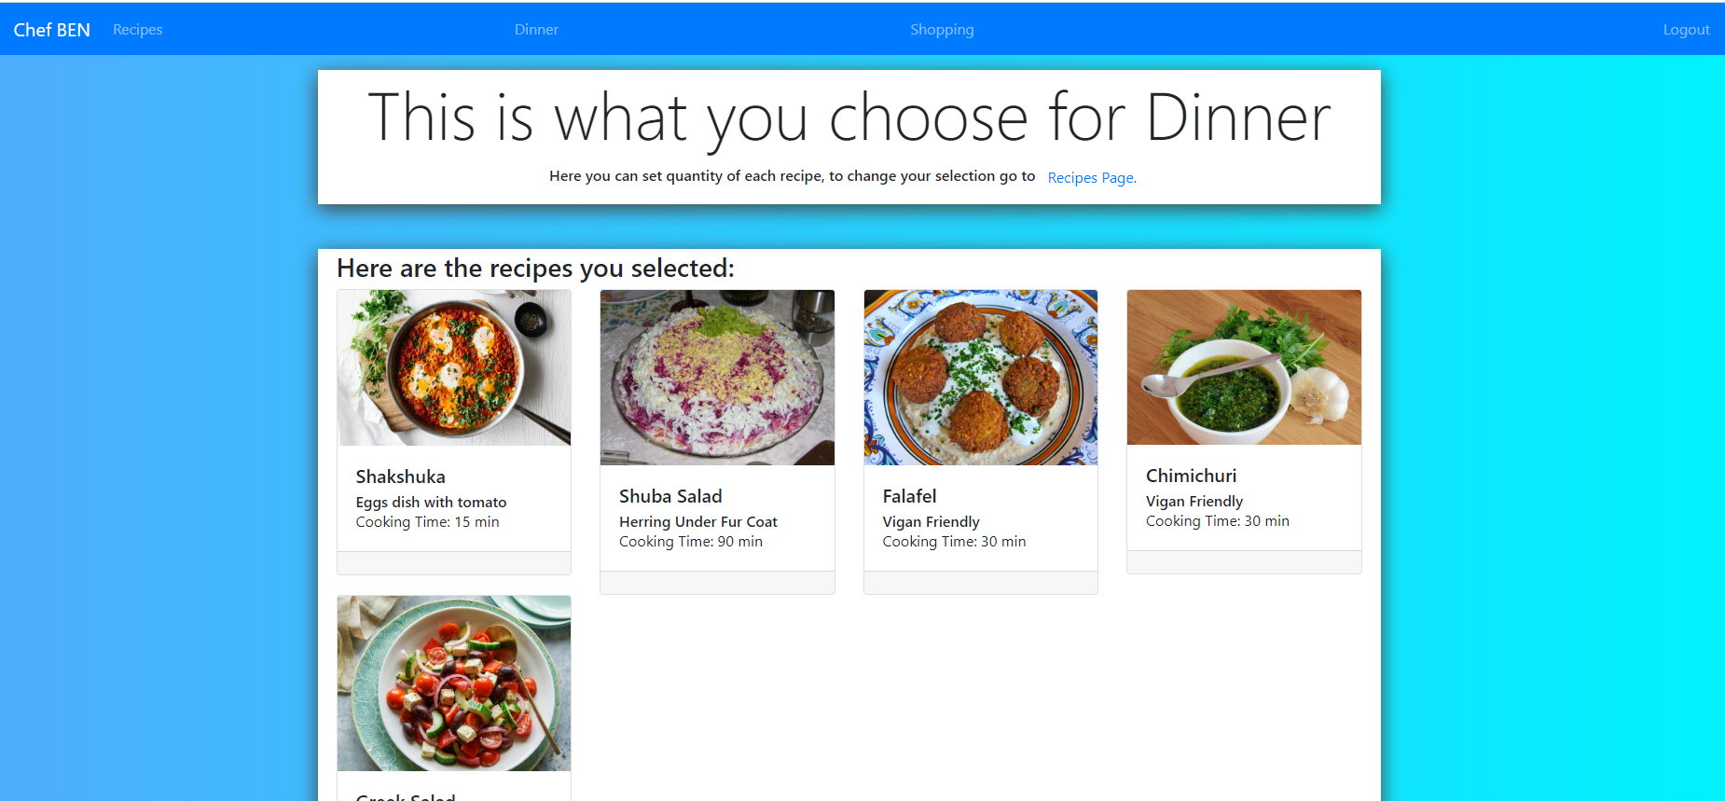
Shopping List Page:
